quadrant dynamic histogram equalization (QDHE)

Initially, the proposed QDHE algorithm separates the histogram into four (quadrant) sub-histograms based on the median of the input image. Then, the resultant sub-histograms are clipped according to the mean of intensity occurrence of input image before new dynamic range is assigned to each sub-histogram. Finally, each sub-histogram is equalized. Based on extensive simulation results, the QDHE method outperforms some methods existing in literature, which can be considered as state-of-the-arts, by producing clearer enhanced images without any intensity saturation, noise amplification, and over-enhancement.

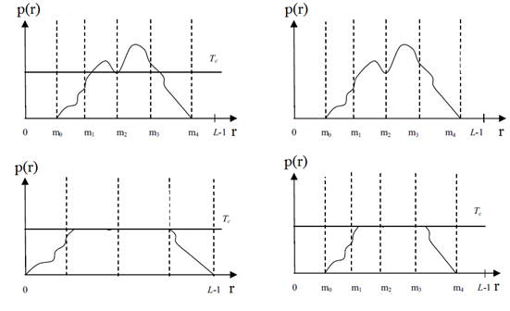

Reference:

<https://dl.acm.org/doi/10.1109/TCE.2010.5681140>